Forum: Human Rights Council
Issue: Measures to protect the rights of transgender people
Student Officer: Vivian Chou
Position: President

Introduction
On average, 2% of the population in each country is transgender, which refers to people whose gender identity does not align with the sex they were assigned at birth. Due to gender normativity, the current society does not recognize transgender or intersex as genders on a spectrum. This stems from the lack of understanding that multiple biological, psychological, and social factors determine a person’s sex and gender, resulting in mixes of genders and gender identities that do not conform to sex. These influential factors could also interact. For example, a person who looks physically female but feels psychologically male may try their best to fit into the socially constructed female category; however, they may end up feeling more strongly about their male gender identity because they resent the female social expectations. When there is no single confirmation for why transgender people exist, the many theories that arise can cause law regulations to ride between waves of supporting and going against transgender rights. The consequences of the lack of rights protecting transgender people include discrimination, higher rates of depression, suicides, and/or death by murder.
The issue regarding the rights of transgender people is complex. Unlike other issues that may have a binary stance, there is an array of stances that involves consideration from multiple perspectives, ranging from the safety of women against sexual violence to the safety of the lives of transgender people. With that said, solving the issue on the rights of transgender people means solving the concern that people might abuse the permission of transgender rights. If these concerns are not properly addressed, they can be easily influenced by politicians or anti-transgender groups. Based on each nation’s value, their stance and solution on this issue would vary vastly.

Definition of Key Terms
Cisgender
An adjective used to describe a person whose gender expression and/or identity aligns with the sex they were assigned at birth.
Gender
The socially-constructed characteristics of primarily male and female members. Unlike sex, gender is socially-constructed.
Gender binary
A system of gender classification with only “female” and “male.”
Gender dysphoria
The sense of unease a person feels due to the way their biological sex and gender identity do not match.
Gender expression
The way a person expresses their gender identity.
Gender identity
A person’s own definition of gender.
Gender normativity
The societal ideal of having only masculine or feminine gender standards, which penetrates into the system society lives in today.
Gender Identity Disorder (GID)
Disorders when a person presents themselves in a way that does not conform to their gender and shows unease due to the way their biological sex and gender identity do not match.
Gender-nonconforming
When gender expression and/or gender identity do not conform to societal expectations.
Intersectionality
The interconnectedness of social categories, such as gender, race, and class, in contributing to discrimination.
Intersex
People born with sex characteristics that are neither fully female nor male.
Non-binary
An adjective describing gender identities that do not conform to the traditional idea of having only two genders, or the male and the female.
Sex
An individual’s biological assignment to a membership of the categories female, male, and intersex at birth. Unlike gender, sex is biologically assigned.
Sexology
The study of sexual anatomy, physiology, and psychology.
Sterilization
A surgical operation or event that makes a person unable to reproduce.
Transgender
An adjective used to describe a person whose gender expression and/or identity do not align with the sex they were assigned at birth.
Transphobia
The strong dislike against transgender people.

Background

History of Transgenderism

The existence of gender non-conforming people is not something new. In 5000~3000BC of Sumeria, the androgynous Gala priests were one of the earliest gender non-conforming people. They used feminine names as tribute to their Sumeiran goddess. In the 18th Century, people from Itelmens of Siberia who were assigned male but identified as female used the third gender name “koekchuch.” In some cultures today, there are also people who do not conform to binary gender standards. In 150 Native American cultures, “two-spirit” who identify as both male and female. In South Asia, Hijras are people who choose to neither identify as a male nor female and usually sterilize themselves.

Despite the long-accepted existence of gender non-conforming people in some cultures, the move towards laws that protect or simply recognize gender non-conforming people has been slow. In 1885, the United Kingdom created a Criminal Law Act in which homosexual behavior is illegal. This lead more people to dress in disguise of their own gender. Since these people have been easily targeted, the safety of transgender people have also been hindered, pushing more transgender people to seek gender reassignment surgeries in which some doctors were already able to do.

The roots of sexology settles at around the 19th century, when some doctors secretively performed gender reassignment surgeries on some people. In 1926, the Hirschfield clinic performed the first ever reassignment operation. These early operations were rather unreliable, with Lili Elbe a transwoman dying two years after her surgery. Newer genrations of sexologists determined that hormone therapy and surgical reassignment is the relatively safer method for gender reassignment. In mid-20th Centry, Christine Jorgensen came out as the first transwoman that sensationalized the media. On the rise of transgender people, Jorgensen’s psychiatrist received several hundred letters from people who wanted a gender reassignment.

Transgender Rights in the 21st Century

On the topic of transgenderism, the implementation of the rights of transgender people is not the problem. The problem lies with the uncertainty of what transgenderism is and what it could bring, before breaking age-old ideologies that surrounds gender norms and transphobia that surrounds transgenderism. As policies in each nation vary, refer to the “Major Parties Involved” section for more.

Why Transgender People Exist

Multiple biological, psychological, and social factors influence sex and gender. Biologically, factors other than XX (for “females”) and XY (for “males) chromosomes, like the bipotential primordium and the SRY, can determine the physical characteristics of an embryo. This is why 17 out of 1000 people are born intersex; however, most parents fit intersex children into a binary gender category by removing parts of their sexual organs. When these people grow up, they may feel that their assigned sex does not match their gender identity. Psychologically, the brain does not have binary “female” and “male” brain characteristics. Since people may feel psychologically different from their assigned sex, gender identity can be more than binary as well. Socially, a person’s life experiences can socially construct their gender identity. In Afghanistan, bacha posh are people who were assigned a female sex but taught to live as a male, which makes them understand their gender as a socially constructed “male”. People may also feel strongly against their sex when facing pressuring social expectations based on sex. According to the American Psychological Association, however, there is not a single factor that makes people transgender.

To qualify as “transgender” in some countries today, a person must be identified as having Gender Identity Disorder (GID) or undergo surgical gender reassignment. Similarly, intersex people are recognized as having a medical disorder. It should be noted that identifying gender non-conforming people as having disorders can cause them life-threatening consequences when seen as people with mental problems instead of people who simply exist on a spectrum.

Concerns Regarding Transgender Rights

The rising level of anti-transgenderism could be attributed to several concerns regarding transgender rights.

One major concern is the co-existence of women and transgender women. Women who have been sexually assulted raised the concern that they are afraid of having both women and transgender women in the same bathroom. Lesbians also think that transgenderism “erases lesbians.” They feel that transgender women would pressure them into sex, showing that transphobia goes beyond the non-LGBTQIA+ community.

Another concern is where transgender people compete in sports. Past research on testosterone showed that high testosterone leads to better sports performance. Transgender women have, thus, been targeted as having more advantage compared to cisgender women. According to Scientific American, however, there has been no clear relationship between testosterone and performance. Reports also show that transgender people face more anxiety, depression, and bullying, which do not serve as advantages. The doubt against transgender women also leads to questioning successful cisgender female atheletes as transgender.

Keep in mind that the above concerns could be relevant reasons or excuses for anti-transgenderism. Above all, this issue stems from gender normativity.

The Political Influences

Partially caused by relevant and irrelevant concerns mentioned, politicians may campaign for anti-transgender laws in order to gain support, especially in democratic countries. In the United States, anti-transgender laws ranging from bans on transgender healthcare, sports participation, and education about transgenderism rose in 2021. In Latin America, bills like banning education on transgenderism have also been voted for. Since the rise of transphobia in the 2020s, politicians have been satisfying deeds in favor of the majority— people against transgenderism. Unless views have changed, such sacrifices would continue for political gains.
Consequences of the Lack of Rights/the Problem
The lack of protection for transgender people results in devastating consequences. Anti-transgenderism bills make transgender people unable to access medical care, deprive them of basic participation rights, and vulnerable to bullying without proper education on the topic. Discrimination pushes transgender people to undergo reassignment before attending university or getting a job. Even simple contracts such as renting and loaning or passing airport security checks may be denied or fail due to transphobia. Such high levels of discrimination lead 40% of transgender people to attempt suicide.

Major Parties Involved

The Independent Expert
The United Nations Human Rights Council (UNHRC) established the Independent Expert to protect people from violence due to their sexual orientation and/or gender identity in 2016. Since then, the mandate has done research across the globe on this issue and visited individual nations periodically to assess the implementation of human rights.
Office of the United Nations High Commissioner for Human Rights (OHCHR)
The OCHCHR is an intergovernmental organization that works with the UNHRC to implement, report on, and campaign for better human rights. The OCHCHR currently reaches out to governments and non-governmental organizations to monitor the human rights of the LGBTI (Lesbian, Gay, Bisexual, Transgender, and Intersex) community and campaign against anti-LGBTI discrimination.

Europe
Europe had always led the implementation transgender rights. Sweden was the first country to legalize gender reassignment. In 2012, Belgium, Denmark, Ireland, Norway, and Malta adopted policies that allowed gender change by declaration. In 2022, Denmark implementated equal treatment laws, including employment, education, health, and other services. However, other nations took a step back. Hungary now prohibits any portrayal of a non-cisgender gender identity under 18. War in Ukraine interferes with gender reassignment transitions due to medical shortages. As anti-LGBTI sentiment rise in the media, the United Kingdom could not carry out its pro-LGBTI reforms.
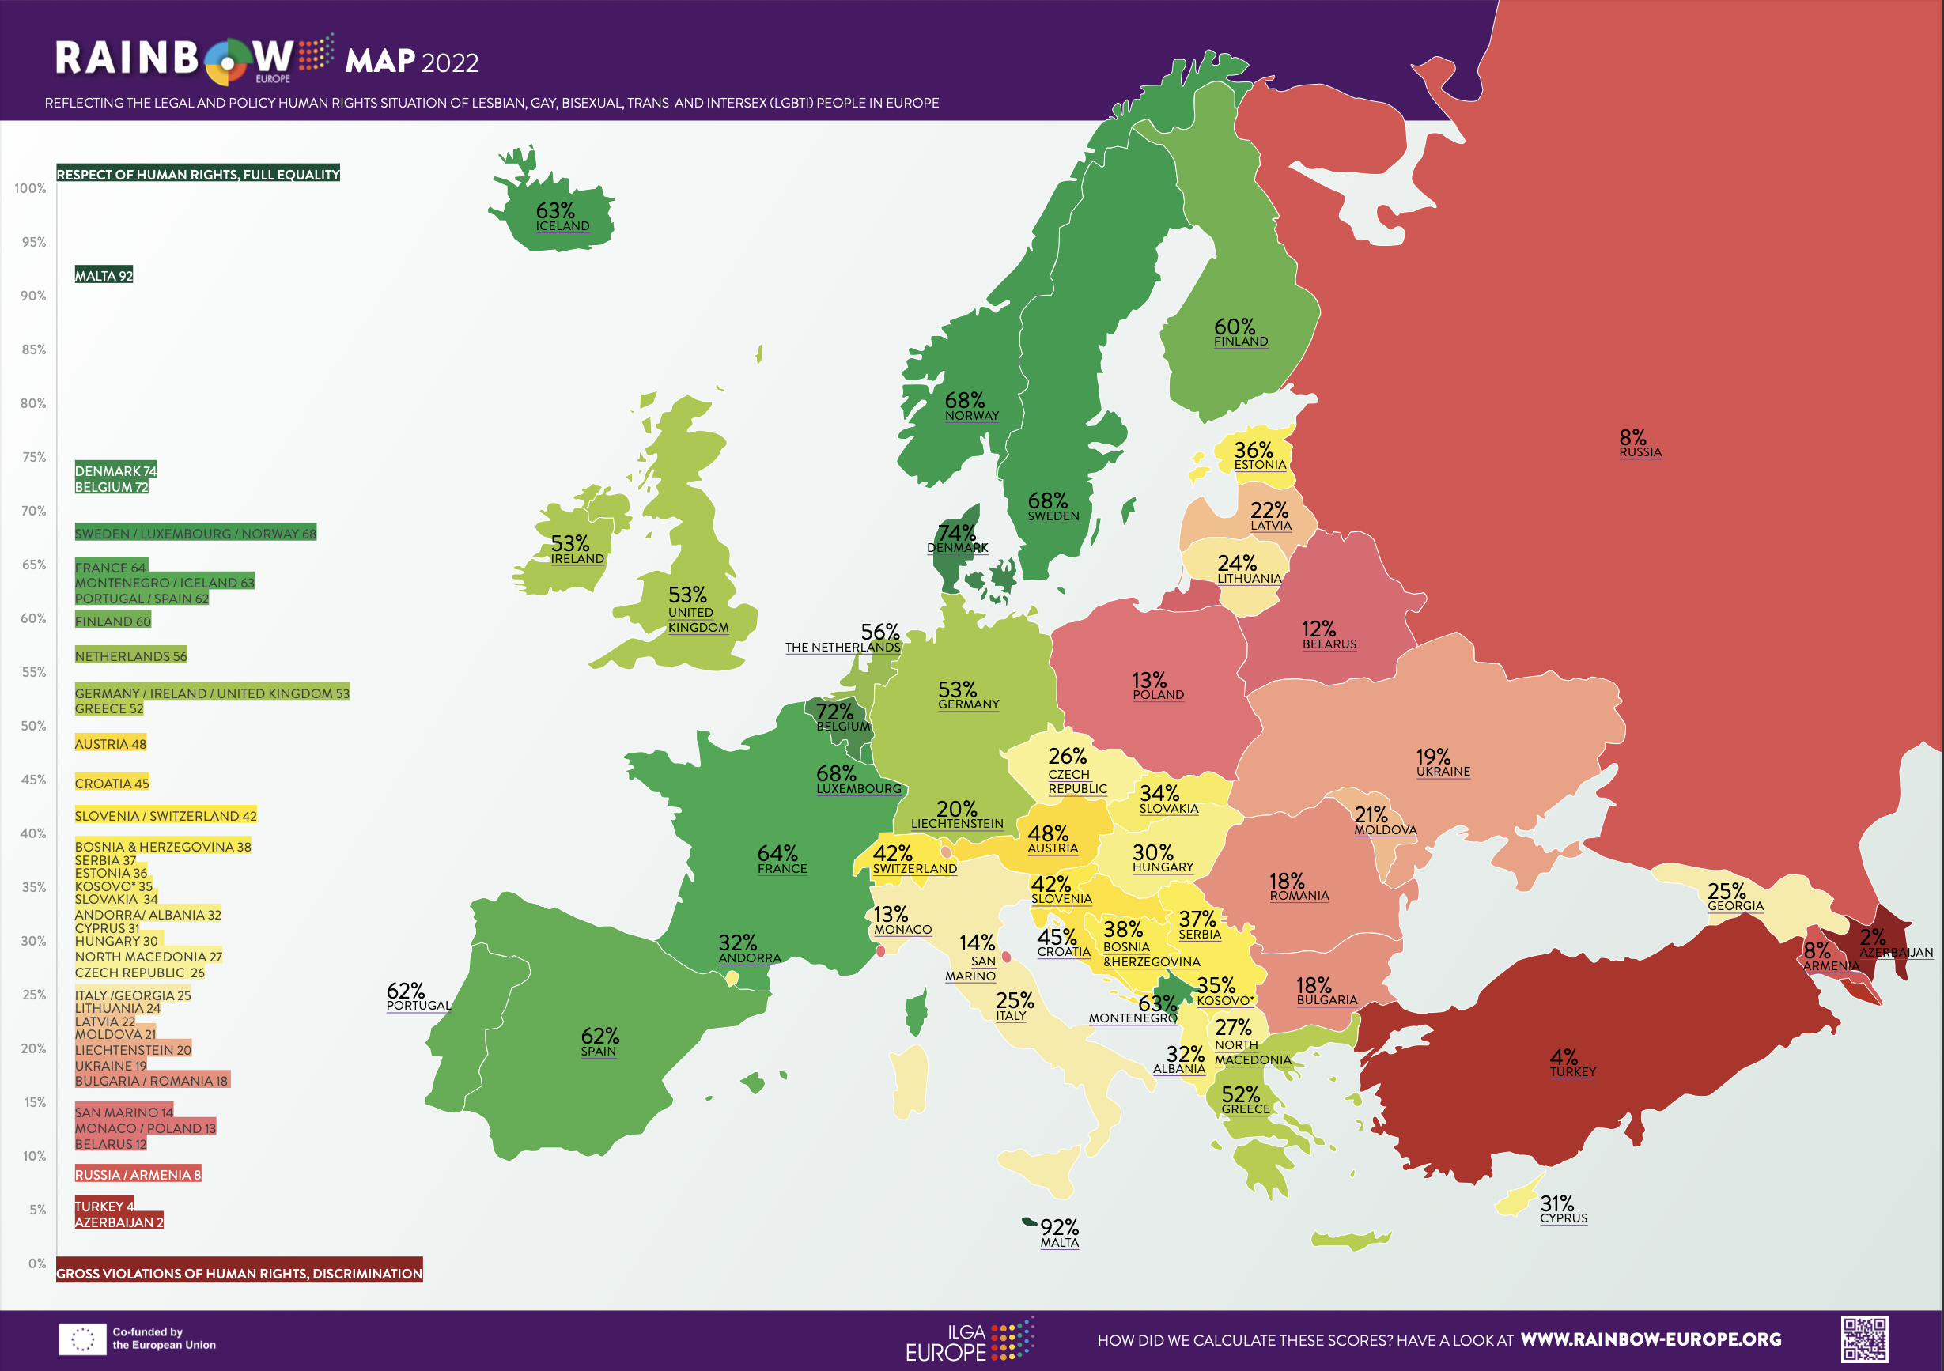
Figure 1: Map of Europe that visualizes how well each nation protects transgender people in 2022.

Asia
Asia has several clusters of nations with similar outlooks toward transgender rights. In South Asia, Pakistan, India, and Bangladesh all recognize a third gender in some ways. East Asia lies with countries with more neutral stances policy-wise. For example, China has not implemented any anti-LGBTQIA+ policies, but neither does it support pro-LGBTQIA+ campaigns. Some Middle Eastern countries, like Kuwait, Oman, Saudi Arabia, and the United Arab Emirates, and South East Asian countries, like Malaysia and Brunei, outlaw non-cisgender gender expression.

Americas
As a mostly democratic continent, the implementation of transgender rights heavily depends on the political climate. As transphobia rises in recent years, politicians in the United States passed bill bans on health care and gender-affirming care and set restrictions towards female or male-only spaces or activities (such as sports). Latin American nations also banned education on transgenderism at school.

Africa
Africa holds one of the most nations that ban transgenderism and same-sex relations. Some religious policies, like Islamic Law, are against LGBTQIA+. Transgender people are often criminalized under same-sex relations laws. Cameroon sentenced transgender people for violation of same-sex relations. Some nations, however, do not have proper regulations implemented. After Ghana accepted protection policies implemented by The Independent Expert, religious and political leaders arrested an LGBTQIA+ group nonetheless. Malawi and South Sudan are two countries explicitly criminalize forms of gender expression.
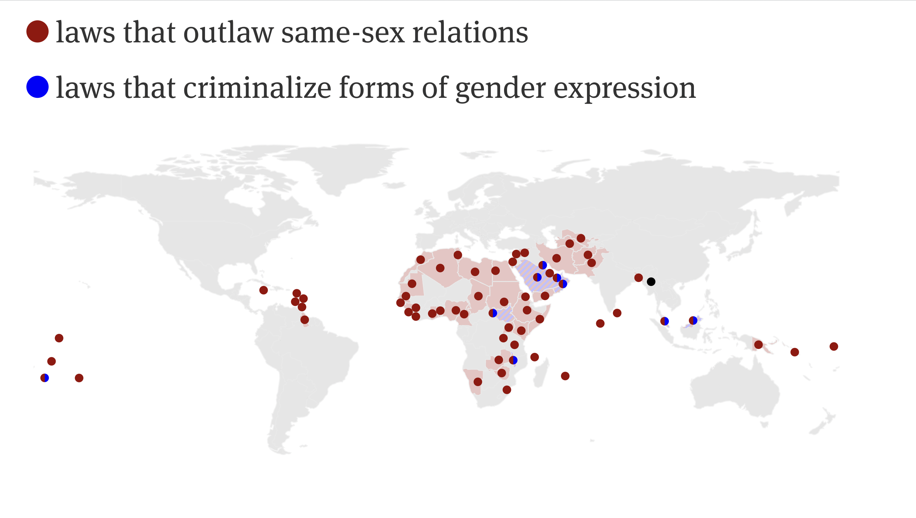
Figure 2: World map that visualizes where same-sex relations and forms of gender expression are outlawed.

Australia
Australia implemented the Sex Discrimination Act in 1984, which prohibits discriminating against people by gender identity. The Australian government recognizes a third sex as Indeterminate/Intersex/Unspecified on personal records.

Timeline of Events
Date | Description of event
1972 | Sweden became the first country to allow gender reassignment legally.
1984 | Australia introduced the Sex Discrimination Act, which prohibits discrimination by gender identity and/or gender expression.
2009 | Pakistan legalized a third gender on legal documentation.
May 16th, 2012 | Argentina allowed people above 18 to choose their gender identity, receive gender reassignment, and change gender on official documents without legal or medical approval.
2013 | Sweden removed the mandatory sterilization to reassign gender.
2014 | India recognized a third gender.
30 June, 2016 | The Independent Expert mandate was established by the UNHRC.
2018 | Bangladesh allowed people to vote as a third gender.
June, 2021 | Both the United States and Spain allowed gender change on legal documents through declaration.
2021 | Multiple anti-transgender bills, ranging from banning access to medical care to removing education on transgenderism from school curriculums, were passed in the United States.

Previous Attempts to Resolve the Issue
In the United Nations, intergovernmental organizations like the Independent Expert and OHCHR work with individual nations to implement transgender rights established by the UNHRC. Both organizations visit different nations to assess the local human rights condition, report on the implementation of human rights, and raise awareness of transgender issues. The actions of these organizations, while slow to see progress, make significant changes in the long run, acting as the implementer of UN policies.
Passed resolutions and renewals on The Independent Expert mandate include:
- Mandate of Independent Expert on protection against violence and discrimination based on sexual orientation and gender identity, 15 July 2022 (A/HRC/RES/50/10)
https://documents-dds-ny.un.org/doc/UNDOC/GEN/G22/407/77/PDF/G2240777.pdf?OpenElement
- Mandate of the Independent Expert on protection against violence and discrimination based on sexual orientation and gender identity, 12 July 2019 (A/HRC/RES/41/18)
https://documents-dds-ny.un.org/doc/UNDOC/GEN/G19/221/62/PDF/G1922162.pdf?OpenElement
- Protection against violence and discrimination based on sexual orientation and gender identity, 30 June 2016 (A/HRC/RES/32/2)
https://documents-dds-ny.un.org/doc/UNDOC/GEN/G16/154/15/PDF/G1615415.pdf?OpenElement
Passed resolutions working with the UN OHCHR include:
- Discrimination and violence against individuals based on their sexual orientation and gender identity, 04 May 2015 (A/HRC/29/23)
https://documents-dds-ny.un.org/doc/UNDOC/GEN/G15/088/42/PDF/G1508842.pdf?OpenElement
https://www.ohchr.org/sites/default/files/A_HRC_29_23_One_pager_en.pdf
- Discriminatory laws and practices and acts of violence against individuals based on their sexual orientation and gender identity, 17 November 2011 (A/HRC/19/41)
https://documents-dds-ny.un.org/doc/UNDOC/GEN/G11/170/75/PDF/G1117075.pdf?OpenElement
Other than UN organizations, individual and groups of activists have made gatherings to support the transgender community by reporting and raising awareness on LGBTQIA+ issues. In countries that are against transgender people, LGBTQIA+ groups gather locally in secret. Other international organizations work to report and raise awareness on the LGBTQIA+ community. Some notable groups include:
- https://www.lgbtmap.org/lgbt-movement-overviews/international-lgbt-advocacy-organizations-and-programs
- Outright International
- International Federation for Human Rights (FIDH)
- International Gay and Lesbian Human Rights Commission (IGLHRC)
- International Lesbian and Gay Association (ILGA)
- Amnesty International (International Secretariat)
Businesses have also stepped in to advocate for LGBTQIA+ rights, including companies like Skillshare, Paypal, and Getty Images that target younger generations. In countries that are against LGBTQIA+ promotions, the business advocation model is a better awareness-raising method, as companies usually exist internationally.

Possible Solutions

As the rights of transgender people are a complicated issue and have had a history of having unstable implementations, solutions should create a stable basis for further implementation of transgender rights across the globe.
- To eliminate any failure of transgender rights implementation due to unclear definitions, nations should seek to define the many terms that describe gender non-conforming people today internationally. Terms include but are not limited to “transgender,” “transgender men,” “transgender women,” “intersex,” “third gender,” and gender non-conforming. After the definitions have been established, nations should seek to use the terms specifically in their transgender rights policies. Policies that specify where transgender people would fit in gender binary systems like male-only or female-only bathrooms would also benefit from clear definitions, reducing the concern raised by how a gender non-conforming society would work.
- Since not all nations are receptive to transgenderism, international organizations should continue to raise awareness on the topic of transgenderism. This should be done so in the most objective manner by reporting facts and data only. In countries that have already accepted pro-transgender policies, both international and governmental organizations can seek to promote transgenderism more to prevent social and political climates from interfering with the implementation of transgender rights. Since nations usually advocate for transgender rights in clusters (such as how India, Nepal, and Bangladesh adopt similar policies on having a “third gender”), more countries may become receptive once a country advocates for transgender rights in one area.
- Based on the country's stance, there should also be scientific research done into the transgender phenomenon. On the one hand, settled scientific proof of the rightful existence of transgender people could invite anti-transgender nations to become pro-transgender nations. On the other hand, more extensive studies into different health fields could also help people identify whether they truly desire a gender reassignment surgery or are fine with the way they are to reduce regrets after gender reassignment surgeries.
- The UNHRC should also continue to ask The Independent Expert, OHCHR, and other intergovernmental organizations to monitor the transgender rights implementation process, as they have aided nations in implementing transgender rights.
- Since violence and harassment towards transgender people are human rights violations regardless of the stance on the issue, member nations should seek to implement laws to protect transgender people from violence and harassment. In nations that recognize all people as equal, the implementation of laws to protect all people, regardless of demographic categories like race or gender, could be used instead.
- Lastly, when implementing these solutions, there should always be a group of transgender representatives who contribute to law enforcement decisions and voting procedures, as cisgender people do not always understand how transgender people are best respected. To reduce the bias of only having a few intersectional social categories (such as only white transgendermen) represented in the representative group, International organizations could pick out transgender representatives from different social categories, such as but not limited to sex, gender, sexual orientation, race, ethnicity, religion, and wealth.

Bibliography
Angelo, Paul J., and Dominic Bocci. "Are Latin American Nations Turning Their Backs on LGBTQ+ Rights?" Council on Foreign Relations, 9 Feb. 2021, www.cfr.org/blog/are-latin-american-nations-turning-their-backs-lgbtq-rights. Accessed 13 Jan. 2023.
"Australian Government Guidelines on the Recognition of Sex and Gender." Australian Government: Attorney-General's Department, www.ag.gov.au/rights-and-protections/human-rights-and-anti-discrimination/australian-government-guidelines-recognition-sex-and-gender. Accessed 13 Jan. 2023.
Carbajal, Mariana. "How trans rights are being 'weaponised' by Latin American right-wing populists." openDemocracy, 29 Aug. 2022, www.opendemocracy.net/en/5050/trans-rights-lgbt-latin-america-brazil-bolsonaro/. Accessed 13 Jan. 2023.
Cheng, Nathanael, et al. "The Resilience of East Asia's LGBTQ Community." The Diplomat, 24 Sept. 2021, thediplomat.com/2021/09/the-resilience-of-east-asias-lgbtq-community/. Accessed 13 Jan. 2023.
"Countries that allow transgender people easy status change." France 24, 29 June 2021, www.france24.com/en/live-news/20210629-countries-that-allow-transgender-people-easy-status-change. Accessed 13 Jan. 2023.
Ferris, Kerry, and Jill Stein. The Real World: An Introduction to Sociology. 8th ed., New York City, W. W. Norton, 2022.
Henig, Iszac. "I Chose to Compete as My True, Trans Self. I Win Less, but I Live More." The New York Times, Jan. 2023, www.nytimes.com/2023/01/05/opinion/trans-athlete-swimming.html. Accessed 20 Jan. 2023.
HRC Foundation. "Seven Things About Transgender People That You Didn't Know." Human Rights Campaign, www.hrc.org/resources/seven-things-about-transgender-people-that-you-didnt-know. Accessed 13 Jan. 2023.
"Independent Expert on sexual orientation and gender identity." Office of the United Nations High Commissioner for Human Rights, www.ohchr.org/en/special-procedures/ie-sexual-orientation-and-gender-identity. Accessed 13 Jan. 2023.
Ingle, Sean. "IOC's new transgender guidance criticised as unfair towards female sport." The Guardian, www.theguardian.com/sport/2022/jan/17/iocs-new-transgender-guidance-criticised-as-unfair-towards-female-sport. Accessed 13 Jan. 2023.
"International LGBT Advocacy Organizations and Programs." Movement Advancement Project, www.lgbtmap.org/lgbt-movement-overviews/international-lgbt-advocacy-organizations-and-programs. Accessed 13 Jan. 2023.
"Know Your Rights | Passports." The National Center for Transgender Equality, transequality.org/know-your-rights/passports. Accessed 13 Jan. 2023.
Kottasová, Ivana. "'I wanted to resume my transition at all costs.' Trans Ukrainians uprooted by war struggle to continue treatment." Cable News Network, 5 Dec. 2022, edition.cnn.com/2022/12/03/europe/ukraine-war-trans-challenges-intl-cmd/index.html. Accessed 13 Jan. 2023.
"LGBTI people." Office of the United Nations High Commissioner for Human Rights, www.ohchr.org/en/topic/lgbti-people?gclid=CjwKCAiA2fmdBhBpEiwA4CcHzaRk_cRNlZA2gezk2GVA_MkLRdpMqaMJ_mF4lv2uAKdOlSf-j9G4hRoCyJ4QAvD_BwE. Accessed 13 Jan. 2023.
Natividad, Ivan. "Why is anti-trans violence on the rise in America?" Berkeley News, 25 June 2021, news.berkeley.edu/2021/06/25/why-is-anti-trans-violence-on-the-rise-in-america/. Accessed 13 Jan. 2023.
"Outlawed: 'The Love That Dare Not Speak Its Name.'" Human Rights Watch, internap.hrw.org/features/features/lgbt_laws/. Accessed 13 Jan. 2023.
"Rainbow Europe Map and Index 2022." ILGA-Europe, 5 12 2022, ilga-europe.org/report/rainbow-europe-2022/. Accessed 13 Jan. 2023.
Reid, Graeme. "Progress and Setbacks on LGBT Rights in Africa — An Overview of the Last Year." Human Rights Watch, www.hrw.org/news/2022/06/22/progress-and-setbacks-lgbt-rights-africa-overview-last-year. Accessed 14 Jan. 2023.
Ronan, Wyatt. "2021 Officially Becomes Worst Year in Recent History for LGBTQ State Legislative Attacks as Unprecedented Number of States Enact Record-Shattering Number of Anti-LGBTQ Measures Into Law." Human Rights Campaign, 7 May 2021, www.hrc.org/press-releases/2021-officially-becomes-worst-year-in-recent-history-for-lgbtq-state-legislative-attacks-as-unprecedented-number-of-states-enact-record-shattering-number-of-anti-lgbtq-measures-into-law. Accessed 13 Jan. 2023.
Statista Research Department. "Share of people identifying as transgender, gender fluid, non-binary, or other ways worldwide as of 2021, by country." Statista, 9 Jan. 2023, www.statista.com/statistics/1269778/gender-identity-worldwide-country/. Accessed 13 Jan. 2023.
Strangio, Chase, and Gabriel Arkles. "Four Myths About Trans Athletes, Debunked." American Civil Liberties Union, www.aclu.org/news/lgbtq-rights/four-myths-about-trans-athletes-debunked. Accessed 13 Jan. 2023.
Sun, Simón(e) D. "Stop Using Phony Science to Justify Transphobia." Scientific American, 13 June 2019, blogs.scientificamerican.com/voices/stop-using-phony-science-to-justify-transphobia/. Accessed 13 Jan. 2023.
"Sweden is rated gay-friendly and the law aims to protect your right to be who you are." Sweden.se, sweden.se/life/equality/gay-rights-in-sweden. Accessed 13 Jan. 2023.
"Transgender." The Australian Human Rights Commission, humanrights.gov.au/quick-guide/12104. Accessed 13 Jan. 2023.
"Transgender People, Gender Identity and Gender Expression." American Psychological Association, www.apa.org/topics/lgbtq/transgender. Accessed 20 Jan. 2023.
"Trans rights: Legal gender recognition in Asia and the Pacific." The School of Oriental and African Studies University of London, 28 June 2017, study.soas.ac.uk/trans-rights-gender-asia-pacific/. Accessed 13 Jan. 2023.
Turban, Jack. "Trans Girls Belong on Girls' Sports Teams." Scientific American, 16 Mar. 2021, www.scientificamerican.com/article/trans-girls-belong-on-girls-sports-teams/. Accessed 13 Jan. 2023.
"US: Anti-Trans Bills Also Harm Intersex Children." Human Rights Watch, 26 Oct. 2022, www.hrw.org/news/2022/10/26/us-anti-trans-bills-also-harm-intersex-children. Accessed 13 Jan. 2023.
Waterson, Jim, editor. "BBC says article on trans women did not meet accuracy standards." The Guardian, 1 June 2022, www.theguardian.com/media/2022/jun/01/bbc-article-trans-women-did-not-meet-accuracy-standards. Accessed 13 Jan. 2023.
Whittle, Stephen. "A brief history of transgender issues." The Guardian, 2 June 2010, www.theguardian.com/lifeandstyle/2010/jun/02/brief-history-transgender-issues. Accessed 13 Jan. 2023.

